**1.Introduction**

**What are chatbots?**

A chatbot is a program that communicates with you.It is a layer on top of, or a gateway to, a service. Sometimes it is powered by machine learning. the chatbot gets smarter the more you interact with it. Or, more commonly, it is driven using intelligent rules (i.e. if the person says this, respond with that). ChatBot offers commands, searching, and letting you complete a number of tasks after you've said the "OK " or "Hey " wake words. It is designed to give you conversational interactions.

Once you've started talking to System, it listens for a response without needing a trigger phrase all the time. System can also recognized voice profiles for different people, so it knows who is talking to it and can tailor the responses accordingly. You can also ask for multiple things at the same time.

The services a chatbot can deliver are diverse. Important lifesaving health messages, to check the weather forecast or to purchase a new pair of shoes, and anything else in between. The term chatbot is synonymous with text conversation but is growing quickly through voice communication…(other voicechatbots are available!) Consumers spend lots of time using messaging applications (more than they spend on social media). Therefore, messaging applications are currently the most popular way companies deliver chatbot experiences to consumers.

**How do chatbots work?**

There are broadly two variants of chatbots. One follows a set of rules, flows, and triggers to respond to very specific commands. A simple example might be a chatbot that tells you the weather forecast for a location. A user might ask “weather forecast London” and the chatbot would find the answer and respond. This type of chatbot is only as smart as the developers who created it and thought of every eventuality of conversation.

The other variant uses machine learning to try to understand the sentiment and meaning of the language used, to not rely on preplanned commands. A user might ask “what’s been happening in London lately?” and the chatbot might deliver the latest BBC News headlines for London.

This type of chatbot learns from all the conversations it has had to improve accuracy and understanding over time

Artificial intelligence chatbots are text- or voice-based interfaces that provide support and connect human users with the services or information they need by simulating a traditional person-to-person conversation. What’s more, when a chatbot is ready to interact with live customers, businesses can implement smart feedback loops. This means that during a conversation, when customers ask a question, a chatbot can deliver a couple of intelligent answers with options like “Did you mean a, b, or c”. The way the customer respond will help to reinforce the bot’s understanding and train the machine learning model.

1. **Literature Review**

In this section we outline the following main aspects of chatbots based on our finding from the literature review: implementation approaches, available public database used in previous data-driven approaches to chatbot implementation, the main evaluation methods for measuring the performance of chatbots and the application of chatbots in different domains.

* 1. **Implementation Approaches to Chatbots**

In this section, we will give an overview of chatbots’ implementation methods. We will distinguish between Rule-based chatbots, and Artificial Intelligence (AI) based chatbots. Within AI-based chatbots, we will further distinguish among Information-Retrieval chatbots and Generative Chatbots. We will also discuss drawbacks and limitations of each implementation approach, as well as recent improvements.

* 1. **Rule-Based Chatbots**

The very first attempts at chatbots’ implementation were rule-based. Rule-based models are usually easier to design and to implement, but are limited in terms of capabilities, since they have difficulties answering complex queries. Rule-based chatbots answer users’ queries by looking for patterns matches; hence, they are likely to produce inaccurate answers when they come across a sentence that does not contain any known pattern. Furthermore, manually encoding pattern matching rules can be difficult and time consuming.Furthermore, pattern matching rules are brittle, highly domain specific, and do not transfer well from one problem to the other

1. **Objectives**

In our project we are reduce compile run time of the project it is better work than other chatbots. This is work on multitasking other chatbots are work on only for their purpose. So that’s why we are create the multitasking chatbot system. The chatbot system is performed on online platform and search offline files.

The high-level view of the final objective is to design a scalable and easily maintainable multilingual chatbot solution that can interface with the company’s existing customer support software. It should serve as the first communication layer in the company’s customer service and provide a way for users to send free-form text messages to help them with the most common issues they encounter regarding the company’s products. In short, it should replicate the menial tasks performed by customer service agents on a daily basis.

Accuracy of other project is 70 to 80 % but we are cover the accuracy 85 to 90 % .

User request analysis is the first and most relevant task a chatbot performs. It is the analysis of a user’s request which is used to identify intent and [extract relevant entities](https://www.expert.ai/blog/entity-extraction-work/?&). A chatbot’s capacity to understand the language and context of a request is critical to its ability to provide an accurate response.

**4.Methodology**

Our approach for conducting this literature survey study consists of two stages. Each stage involves several activities. In the first stage, we identify relevant search terms to literature work on the topic, and then we identify appropriate databases of research articles. Then, we collect research articles on chatbots from the selected databases. These activities are focused on information gathering about the topic.

**4.1 Information Gathering :**

Search Terms and Databases Identification

We have used three large publishers’ databases for identifying research articles on chatbots. These are IEEE, ScienceDirect and Springer. These databases provide a good assortment of peer reviewed articles in the fields of Natural Language Processing, Artificial Intelligence, and Human-Computer Interaction. In addition to those databases, we have searched for publication on arXiv, Google Scholar and JSTOR because they provided a considerable number of publications and material.

We initially started querying the selected databases using a seed search term “chatbot” which broadly described the subject matter. From some of the articles identified using our seed term, we identified the following new search terms: “conversational modelling”, “conversation systems”, “conversational system”.

**4.2 Article Filtering and Reviewing :**

**4.2.1 Filtering Articles:**

After we have identified several search terms, we have queried the databases. The search terms returned high quantities of research articles. The initial search result returned thousands of pieces of literature spanning from 1970s to 2021. In order to reduce the number of articles for analysis to a manageable number, we have filtered the search results based on publication date. We focused on articles published between 2007 and 2021.

After the first filtering step, we applied a second filtering operation by selecting articles based on their title. The objective was to focus only on relevant articles for our study. Initially, we searched for articles in journal databases, such as IEEE; ScienceDirect; Springer; and JSTOR as we had institutional access to them to retrieve full text of articles, with specific keywords. The search result contained several thousands of peer reviewed published articles. We analyzed the title of each article returned to determine its relevance to our study.

**4.2.2 Reviewing Articles:**

Chatbot History and Evolution: this aspect encompasses all papers that presented a detailed description of chatbots’ evolution over time. This category is fundamental since it helped us understand the trends and technologies that ascended or discarded over time, indicating the evolution of the chatbot. It also helped us discover how and why chatbots emerged and how their applications and purposes changed over time. Section 2 offers overview of our finding on chatbots history and evolution.

These categories emerged from the literature review. The articles we reviewed covered one or more of these categories, often stated in the title or the abstract. It could be argued that these categories are widespread in the literature because they are strictly connected with chatbots development.

* **Example of Sample Training Set**:

Class: Greetings

*“How are you doing?”*

*“Good morning”*

*“Hi, there!”*

* **Sample Input Sentence Classification**:

Input: “Hello, good morning.”

*Term: “Hello” (no matches)*

*Term: “Good” (class: Greetings)*

*Term: “morning” (class: Greetings)*

*Classification: Greetings (score=2)*

**4.3 Modules**

In this project, the chatbot model consist of three modules.

Modules are:

**4.3.1 NLU module:** This module is responsible for obtaining and interpreting the conversation text (convert unstructured data to structured data). Identify the entities in the text which will be used to understand the intent of the text. i.e., What is the weather in Chennai? Entity-list: Location: Chennai, Measure: weather.

**4.3.2 State Machine module:**

This module is responsible for maintaining the conversation state — context of the dialogue.

i.e., where are we in the conversation? Are we at the start or end of the conversation? Do we have all the entity details to execute an API query? It gets tricky here as modeling natural conversation as a state machine is very hard. Conversation can take any route and enforcing constraints and handling edgecases will be very hard and chaotic.

**4.3.3 Dialogue NLG module:**

This module talks back to the user. It gets the response from the state machine and then relays the results to the users. Natural language generation is also an active area of research. This module handles the chat user interface .

**4.4 Flow Diagram of Chatbot**

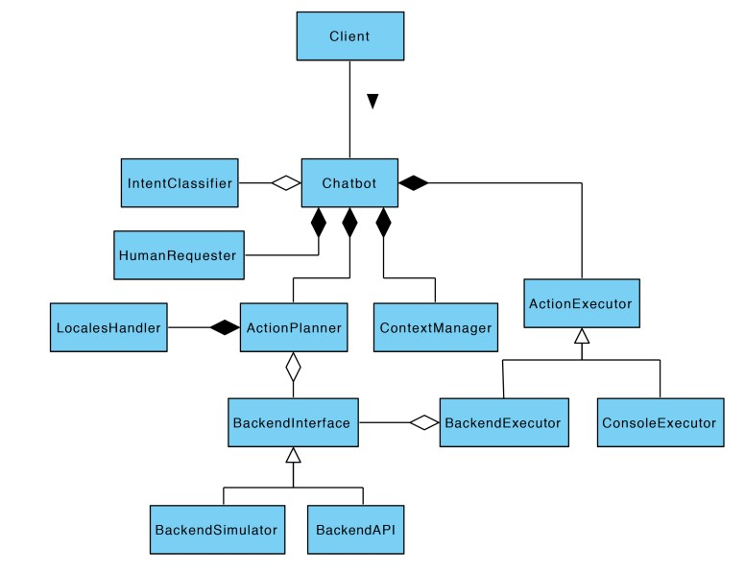

* Fig 4.1 : Agent environment model

As can be clearly seen from this diagram, the chatbot is made of several components each solving one particular problem. The component labelled Client at the top of the diagram is simply a generic client program that makes use of the chatbot. It can simply be a terminal client or a more complicated dynamic online listener that fetches new tickets when they are issued through the system.

The chatbot’s 5 main components are : Intent Classifier, Human Requester, Action Planner, Context Manager, and Action Executor.

**5.Software and Hardware Requirements**

**Software:** CodeBlocks, Dev C++, Firefox/Chrome/Internet Explorer

**Hardware:** Computer

**Backend** **:** C++

**System Requirements :** 8 GB ram or more, 2nd Generation Intel Core and newer.

**Operating System:** Windows 7 or Newer

**6. Design and Implementation**

This chapter will justify the use of certain libraries for the project, as well as discuss the concrete implementation details of the completed system.

**6.1 Libraries used in the implementation:**

**stdio.h :** This header file defines types and macros needed for the standard I/O packed. When you include iostream (iostream.h ) file in your program, this file stdio.h automatically gets included in your program.

**stdlib.h :** This header file declares several commonly used routines like conversion routines, search/sort routines, and other miscellaneous things.

**iostream.h :** This header file declares the basic C++ streams I/O routines.

**iomanip.h :** This file declares the C++ streams I/O manipulation and contains macros for creating parameter manipulators.

**6.2 Generating responses**

Due to the constraints outlined, the approach taken for generating responses is a retrieval-based one. Indeed, doing so allows the maintainers to ensure that the agent does not say something offensive to the user. The module responsible for retrieving the responses is the ActionPlanner and in this case, it contains all the logic that is triggered whenever the user intent is correctly identified. For example, it might call the backend to ensure that the user’s account is not blacklisted or that the delay of the user’s last withdrawal is because it is performed to an international bank account. The responses have a structure that is reminiscent of what customer support agents might actually answer in real life. Thus they are formulated to look a lot like formal e-mails since that is the primary source of tickets customer service receives.

* 1. **Design of algorithm in programming structure**

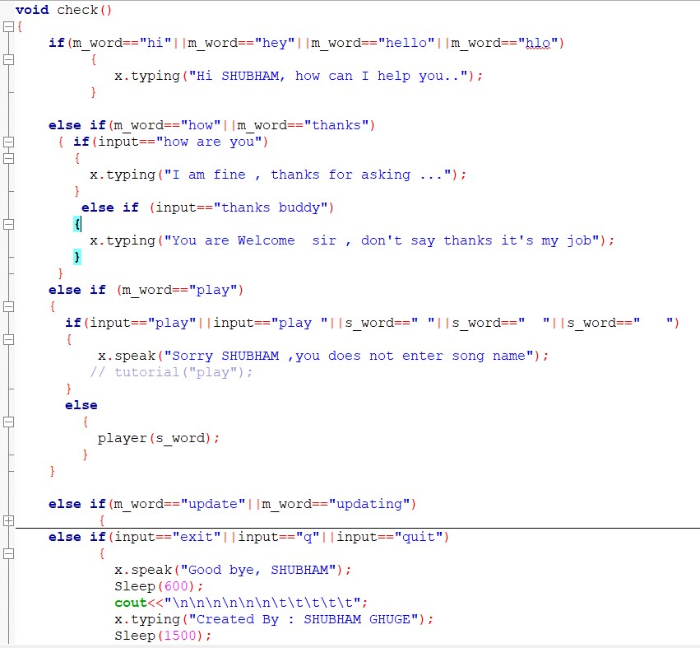

Fig 6.1 : commands used in program

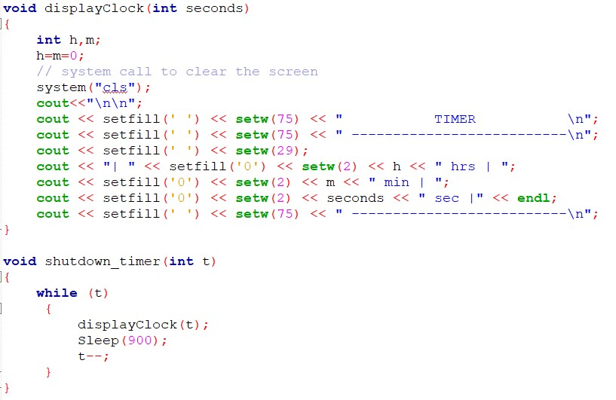

Fig 6.2 : function to display the timer

**6.4 Description of functions**

* + check() – Compare the user input with defined commands.
  + line() – creates new line.
  + repeat() – asks user input.
  + Player() – Search the song from file(songs.txt) then play the song.
  + Install() – creates music folders.
  + Block() – block the websites.
  + Openf() – open the file directory. • Lists() – Show song list.
  + Convert() – Convert ‘space( )’ to ‘underscore’( _ ) and lowercase string
  + Update_song() – Copy song name from different files(List.txt) file into one file (songs.txt).
  + Search() - Generally **searching for a specific element in an array means that potentially all elements must be checked**..
  + Clock() - The clock() function returns the approximate processor time that is consumed by the program .
  1. **List of commands**

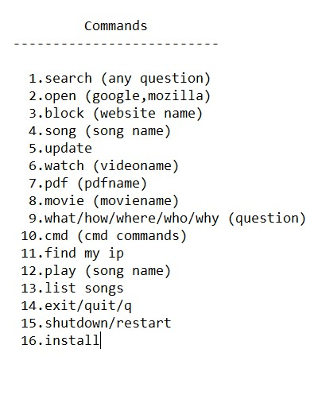

Fig 6.3 : commands for chatbot system

**7.Result and Discussion**

When testing the last prototype we got findings suggesting that the participants did not have a problem with getting information from a chatbot instead of a human. The information that they got was not seen as less trustworthy, this could be supported by the fact that the chatbot provided a source for the information it gave. It has been interesting to investigate how the participants interacted with the chatbot and how they reported on it afterwards. Our findings have some indicators leading towards that a chatbot could be a good alternative for acting as a helpful friend for freshmans at a new school. Still we have to stress the fact that the chatbot was not very intelligent and that the evaluators had to adjust their language to match the chatbots. 11 Because of the scope of the project we did not have time to conduct as much user testing and re-design to the chatbot as we would have liked.

This has an impact on the validity of our research. Through the project we have touched on some theory when making the chatbot, but this should also have a larger focus for higher validity. Even though the participants trusted the information given in this project we cannot say that people trusts a chatbot as much as they trust a human being. There are also biases in our project, one of them is that all the students that we included in the project already knew a lot of the answer the prototype could provide. Another bias is that the information the chatbot provides could be seen as “casual” and are not crucial and/or vital This could have had an impact on the results regarding trustworthiness.

**7.1 Applications of chatbot**

* + **Retail and e-commerce:**

In a highly competitive market like retail and e-commerce, you need to engage in personalized conversations with customers to grab their attention and get them to a purchase decision.

* + **Travel and hospitality:**

Just like e-commerce and retail, Chatbots can provide a range of services in customer service from customizing itineraries to managing bookings and reservations.

* + **Banking, Finance and Fintech:**

Customer issues in banking and finance often require immediate attention. Chatbots provide fast and accurate responses, making them increasingly popular in this space.

* **Healthcare:**

Chatbots have proven to be very helpful in the healthcare industry, especially in recent times when hospitals and other instituitions are required to minimize queues and gatherings.

* + **Billing and insurance processs:**

Chatbots digitize and automate the entire billing and healthcare insurance claims processes.

**7.2 Output:**

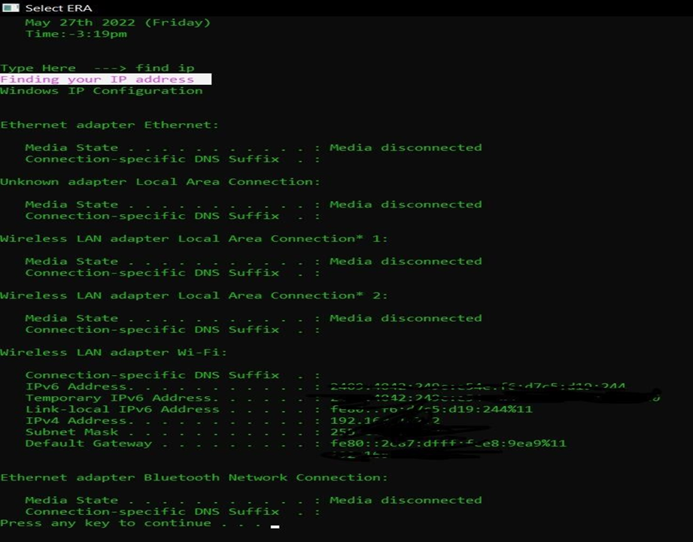

Fig. 7.1 : output of the Chatbot System

**7.3 How the output came ?**

The first participant enjoyed talking to the bot, but stressed the fact that you had to “talk like “a dummy” for it to understand what you were asking. The participant pointed out that this really would have come in handy in his first weeks at the university, as he didn’t always know who to ask - especially if he was in a hurry. He pointed out that the prototype needs to get more features like tell you exam dates, or “if life-hacks, like get your coffee before all of the students have their break”.

The second participant was a bit frustrated that the chatbot wasn’t flexible enough (Fig.3). “I don’t like having to guess what questions to ask”. He would liked more instructions to know how to get more out of the chatbot.

The third participant had also problems with understanding what the chatbot could do. When given a hint for what the chatbot could do, the chatbot did not function properly. Here we tried to restart the system and then the chatbot displayed it´s welcome message一 what it could do. Afterwards it was more clear what the participant could ask it, but the chatbot did not always give the response that the participant wanted.

**8.Conclusion**

When testing the last prototype we got findings suggesting that the participants did not have a problem with getting information from a chatbot instead of a human. It has been interesting to investigate how the participants interacted with the chatbot and how they reported on it afterwards. Our findings have some indicators leading towards that a chatbot could be a good alternative for acting as a helpful friend for freshmans at a new school. Still we have to stress the fact that the chatbot was not very intelligent and that the evaluators had to adjust their language to match the chatbots.

Because of the scope of the project we did not have time to conduct as much user testing and re-design to the chatbot as we would have liked. This has an impact on the validity of our research. Through the project we have touched on some theory when making the chatbot, but this should also have a larger focus for higher validity. Another bias is that the information the chatbot provides could be seen as “casual” and are not crucial and/or vital This could have had an impact on the results regarding trustworthiness.

With that being said we also think that some of our findings could give some insights into how a very small group of people think about using a chatbot to gain information in a school context. This paper we have provided a survey of relevant works of literature on the subject, and we have analysed the state of the art in terms of language models, applications, datasets used, and evaluation frameworks. We have also underlined current challenges and limitations, as well as gaps in the literature.

Despite technological advancements, AI chatbots are still unable to simulate human speech. This is due to a faulty approach to dialogue modeling and a lack of domain-specific data with open access. For Information Retrieval chatbots, there is also a lack of a learnt AI model.

Chatbot modeling is a fascinating challenge that mixes Deep Learning and Natural Language Processing. Despite the fact that the first chatbots were created sixty years ago, the area has continued to grow and provide new and exciting problems. To bridge these gaps, smaller, flexible, less domain dependent models would be beneficial. Improved, scalable, and flexible language models for industry specific applications, more human-like model architectures, and improved evaluation frameworks would surely represent great steps forward in the field.

**9.Future Scope**

Chatbots are becoming popular and are currently most commonly used in messenger applications on social media platforms. While the number of businesses that utilise chatbots has grown, many have yet to realise the true potential and various benefits of implementing chatbots for businesses.Chatbots can bring technological advancements and vastly improve customer engagement. It can communicate with clients to create enhanced lead generation. The chatbot is a perfect tool to make suggestions on everything from products to services, helping you to capture super-targeted leads.Huge amounts of data generates due to the e-commerce platform. So, there is a need to use bot technology and cloud services. But there are few limitations of chatbots that needs to be improved. They can be improved in the following ways :-

* 1. **Put an escalation path in place:**

Where chatbots add most value for businesses is in answering routine questions quickly. If the questioning becomes more complex, the business needs to have an option to escalate the interaction to a human advisor. That advisor should be able to pick up the thread of what has gone before and, where necessary, switch the call from a chat window to a voice interaction.

* 1. **Keep feeding chatbots with new information:**

While chatbots do fulfil an invaluable role within many contact centers, businesses need to realise that implementing and then operating them can be a major commitment.

* 1. **Make chatbots more empathetic:**

Chatbots are usually efficient and a tremendous help in a variety of cases. But, as with any other automated systems, customers engaging with a chatbot can sometimes feel a lack of empathy or find it a struggle to express their emotions during conversations. To do this, the conversation set that is used to train the chatbot before production should cover various emotional situations and emotions and be part of the reporting process on real conversations.

* 1. **Use natural language processing to make chatbots seem friendlier:**

Through Natural Language Processing (NLP), the system learns to recognise real language. This engagement with language allows the software to utilise data to provide customers with personalised information.

* 1. **Use them to collect information in the initial part of conversion:** Start with existing live chat offerings, or social media messaging applications – like Facebook Messenger, and then introduce bots. Once bots have been introduced, use them to automate the repetitive tasks of collecting information at the start of any dialogue and, ultimately, directing the caller to another self-service option or a live advisor.The vast majority of customer interactions will be powered by chatbots in 2023, it is more important than ever for organisations to step up their game in terms of learning from customer interactions. In such ways, the system of chatbot can be improved. After that, the use of chatbot can be a major and promising commitment in the future.

**10.References**

1. Lison, P.; Tiedemann, J. OpenSubtitles2016: Extracting Large Parallel Corpora from Movie and TV Subtitles. In Proceedings of the Tenth International Conference on Language Resources and Evaluation (LREC’16), Portorož, Slovenia, 23–28 May 2016; European Language Resources Association (ELRA): Portorož, Slovenia, 2016; pp. 923–929.
2. Li, Y.; Su, H.; Shen, X.; Li, W.; Cao, Z.; Niu, S. DailyDialog: A Manually Labelled Multi-turn Dialogue Dataset. In Proceedings of the Eighth International Joint Conference on Natural Language Processing (Volume 1: Long Papers), Taipei, Taiwan, 27 November–1 December 2017; Asian Federation of Natural Language Processing: Taipei, Taiwan, 2017; pp. 986–995.
3. Danescu-Niculescu-Mizil, C.; Lee, L. Chameleons in imagined conversations: A new approach to understanding coordination of linguistic style in dialogs. In Proceedings of the Workshop on Cognitive Modeling and Computational Linguistics, Portland, OR, USA, 23 June 2011.
4. Cummings, M., 2004. Automation bias in intelligent time critical decision support systems, in: AIAA 1st Intelligent Systems Technical Conference ( p.n. 6313).
5. Hung, V., Gonzalez, A., & DeMara, R. (2009, February). Towards a context-based dialog management layer for expert systems. In Information, Process, and Knowledge Management, 2009. eKNOW'09. International Conference on (pp. 60-65). IEEE.
6. Jung, M., Hinds, P., 2018. Robots in the Wild: A Time for More Robust Theories of Human-Robot Interaction. ACM Trans. Hum.-Robot Interact. 7, 2:1–2:5.
7. Lazar, J., Feng, J. H., & Hochheiser, H. (2017). Research methods in human-computer interaction. Morgan Kaufmann.